|  |  |
| --- | --- |
| **Feature: Bill of Material Cost Calculation** |  |
| **Customer: Pacon Mfg Inc.** |
| **Functional Requirements Document (FRD)** |
| **Architect: Palavi Rajgude** |
|  | |

**Document Control**

|  |  |  |
| --- | --- | --- |
| **Version** | **Date** | **Comment** |
| ORIGINAL v1.0 |  |  |

**Open Items**

|  |  |  |  |
| --- | --- | --- | --- |
| **Issue** | **Date** | **Page #** | **Comment** |
|  |  |  |  |

TABLE OF CONTENTS

1. Overview 3

2. Process 4

3. Test Cases 12

# **Overview**

Pacon requires a customization on the Bill of Material record to utilize a calculation button option that will pick up Units of Measure utilized on Bill of Material Record as well as Item attributes associated per Inventory Item. Calculation will pull current item cost when ‘Calculate’ button is pushed and display in custom column field on BOM revision record.

It will display total Component Cost for an Assembly item based on Top Level assembly and roll-up of costs on subsequent sub-assembly or component end-item revision records.

# **Process**

**2.1. Top Level Assembly and Sub Assembly Records Present in Bills of Materials Record List.**

**2.1.1. Top Level Assembly Record Present in Bills of Materials Record List Shown in below fig.**

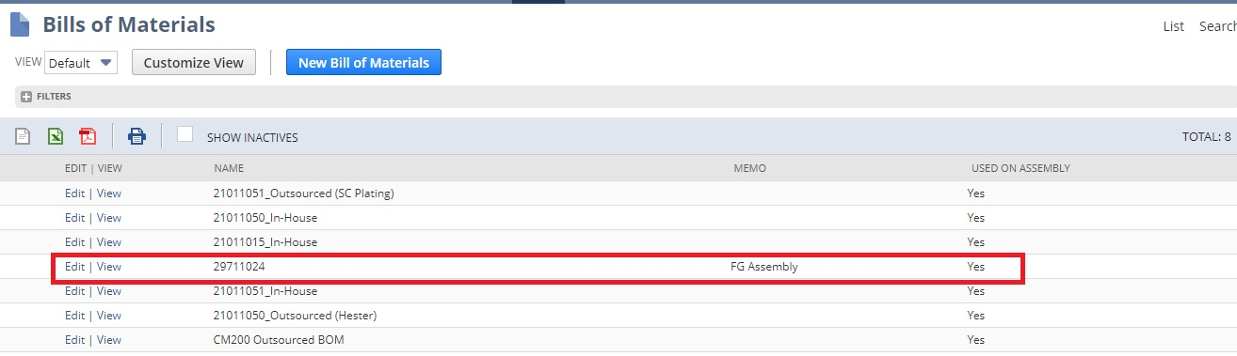

In Bills of Materials Record List, **‘29711024’** is Top Level Assembly Record because this record has set ‘FG Assembly’ on Memo field.

Bill of Material Revision Record Present on Line level in Top Level Assembly Record (**‘29711024’)** Shown in Below Fig**.**

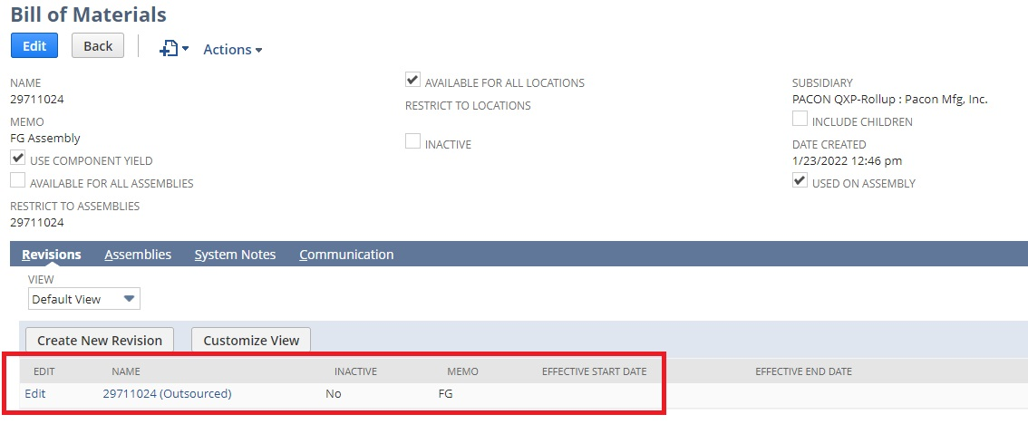

Bill of Materials Revision Record is also known as Top-Level Assembly Record and it Contain Sub Assembly Records.

**2.1.2 ‘Cost Calculator’ Button is Available on ‘Bill of Material Revision’ Record.**

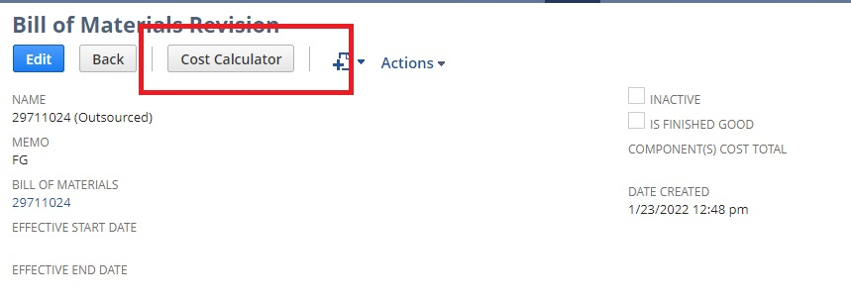

Bill of Material Revision Record will have Cost Calculator button activated by workflow.

When customer hit the button then script will take cost from calculated cost line field of all components and calculated their sum and set to components cost total field shown in fig.

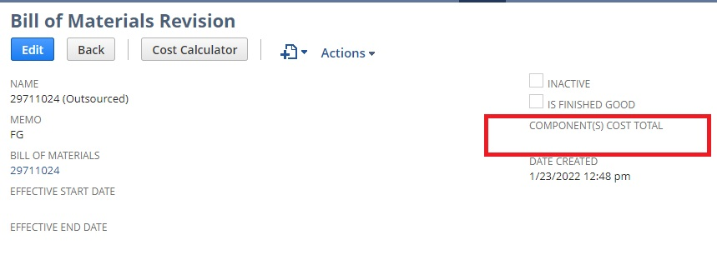

In Top Level Assembly Record there is Sub assembly records and each sub assembly records have calculated cost present in line-item records.

**2.1.3. Sub Assembly Records Present in Bills of Materials Record List Shown in below fig.**

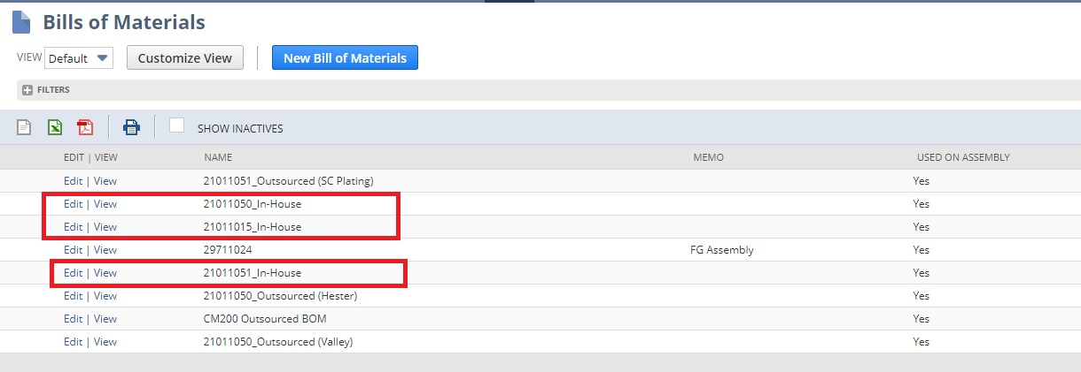

In Bills of Materials Record List, **21011050_In-House, 21011015_In-House and 21011051_In-House** Records are Sub Assembly Records and Also present in Top Level Assembly Records.

Each Sub Assembly Records have own Bill of Material Revision Records Shown in Below fig.

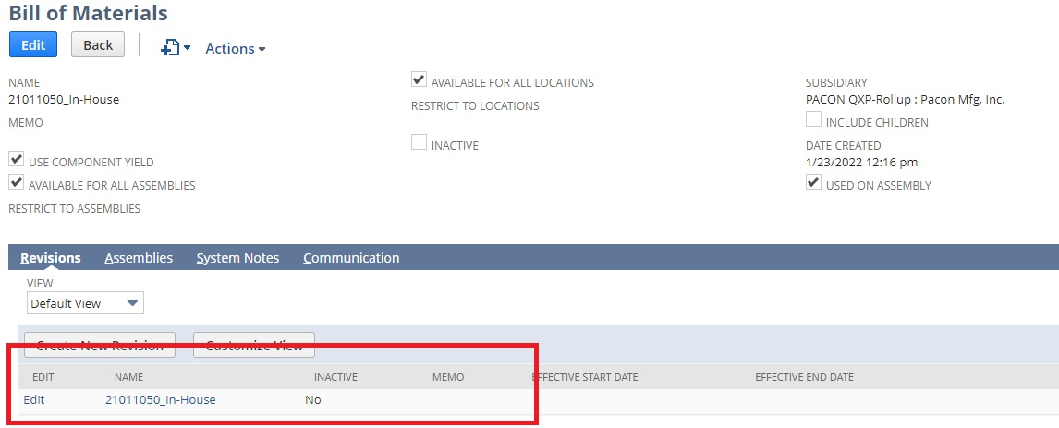

Each Bill of Material Revision Record have own Component Items Shown in below fig.

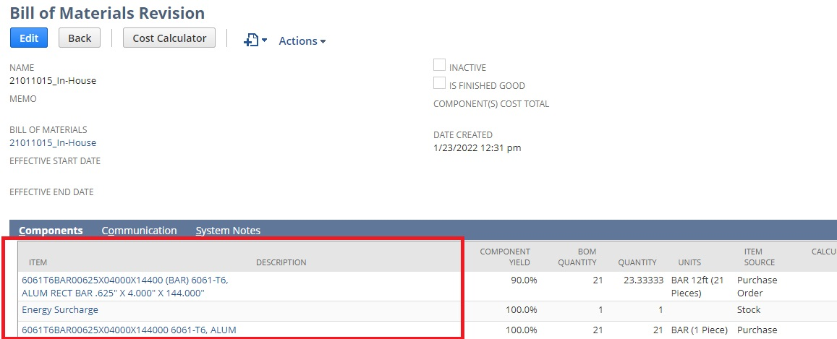

Script will get Cost from Item Records and set to calculated cost line field on all line level items record and then sum of all calculated cost set to components cost total field on Bill of Material Revision Record.

**2.2. Get Cost from Inventory Item Records.**

Script will get Cost from Inventory item record present in Bill of Material Revision Record.

Get cost from purchase price field in purchasing subtab on Item Records.

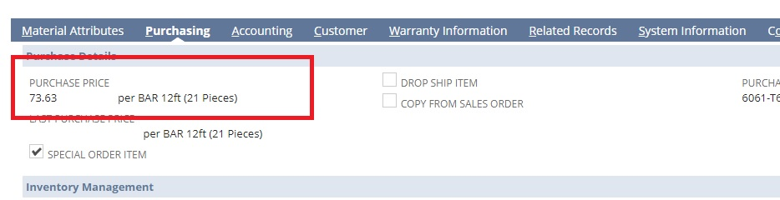

Open Top Level Assembly Record same as Bill of Material Revision Record Name.

In that Top Assembly Record, Quote price level present in Sales/Pricing Subtab.

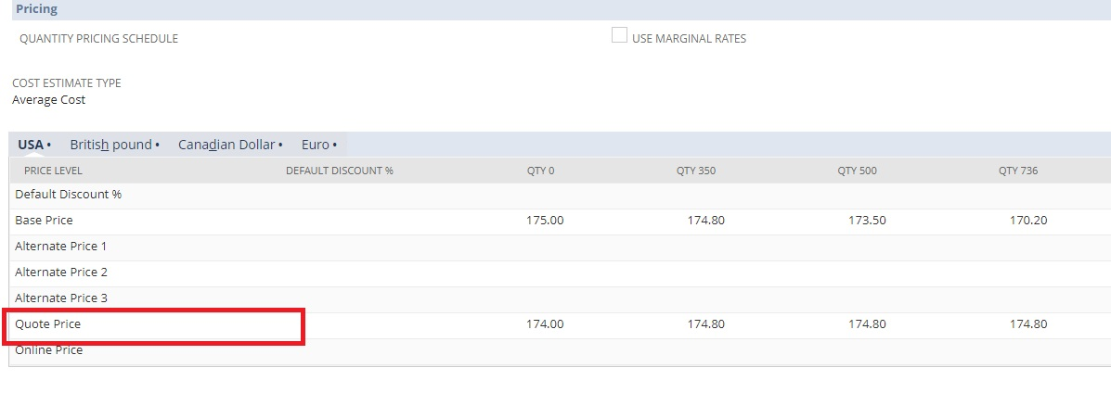

**2.3. Create Quote Record to Set Quote Total Price.**

Step1: User utilizes Cost Calculation script on BOM revision record

Step2: Calculated Cost of components on Bill of Materials of Assembly item flow to Quote Price on Assembly Item record Price Level.



Step3: User creates Quote in system

Step4: User selects Price Level ‘Quote Price’ on Quote line which holds calculated cost of all component end items on Bill of Materials record.

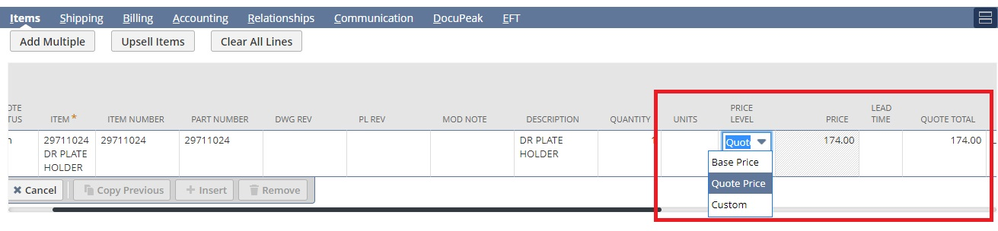

**2.4. ‘IS FINISHED GOOD’ Checkbox Present on Bill of Materials Revision Record.**

If ‘IS FiNISHED GOOD’ checkbox is checked then it will be finished good or top-level assembly record.

If ‘IS FiNISHED GOOD’ checkbox is unchecked then it will not specify as sub assembly bill of material revision record.

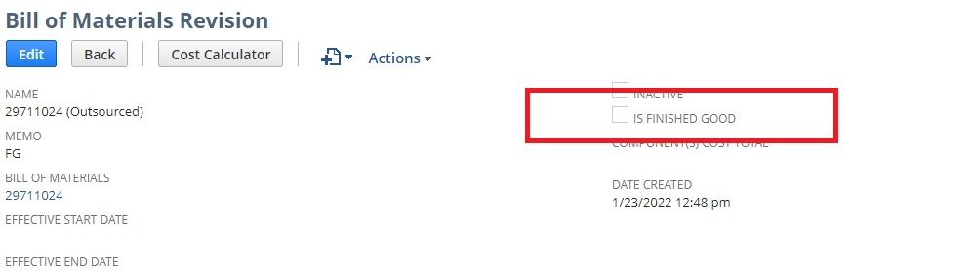

**2.5. Script Deployed on Bill of Material Revision Record.**

Step1: Bill of Material Revision Record will have Cost Calculator button activated by workflow.

Step2: User Pushes button which will run a script that will look at the Component End Item(s) on the Revision record and pull in Average Cost of Component Item factoring in quantity on BOM revision and Units specified on Units column.



Step 3: Cost rollup per Item will flow to ‘Conversion’ field on Line item of Revision record

Step 4: Field in Body of Revision record will Calculate all Line item ‘Conversion’ fields and Total Amount will be displayed in header field ‘Component(s) Cost Total.



# **Test Cases**

To Be Completed by QA:

|  |  |  |  |
| --- | --- | --- | --- |
| **Test Case #** | **Scenario** | **Expected Result** | **Actual Result** |
| 1 |  |  |  |
| 2 |  |  |  |

1. Signatures

By signing this document, both the Client and Pacon agree that the requirements and assumptions are accurate and adequate to begin the implementation. If a requirement, flow, customization, configuration, or document is not stated in this Requirements Document or in its related SOW and Change Order, then it is assumed to be out of scope and not to be included in the implementation. Any changes to the flows, requirements, or assumptions may result in work that falls outside the scope of work that has been defined and may extend the targeted milestones and go-live dates and shall be subject to a change order or a separate statement of work and if necessary, additional costs.

|  |  |  |
| --- | --- | --- |
| **Pacon Mfg Inc.** |  | **Caravel** |
| **Name:** |  | **Name:** |
| **Title:** |  | **Title:** |
| **Signature:** |  | **Signature:** |
| **Date:** |  | **Date:** |